EXPERIMENT NO 8
i) On mouse over event
<!DOCTYPE html>
<html>
<head>
<script>
function bgChange(bg) {
document.body.style.background = bg;
}
</script>
</head>
<body>
<h2>Change background color</h2>
<p>Mouse over the squares!</p>
<table style="width:300px;height:100px">
<tr>
<td onmouseover="bgChange(this.style.backgroundColor)"
onmouseout="bgChange('transparent')"
style="background-color:Khaki">
</td>
<td onmouseover="bgChange(this.style.backgroundColor)"
onmouseout="bgChange('transparent')"
style="background-color:PaleGreen">
</td>
<td onmouseover="bgChange(this.style.backgroundColor)"
onmouseout="bgChange('transparent')"
style="background-color:Silver">
</td>
</tr>
</table>
</body>
</html>

Output:
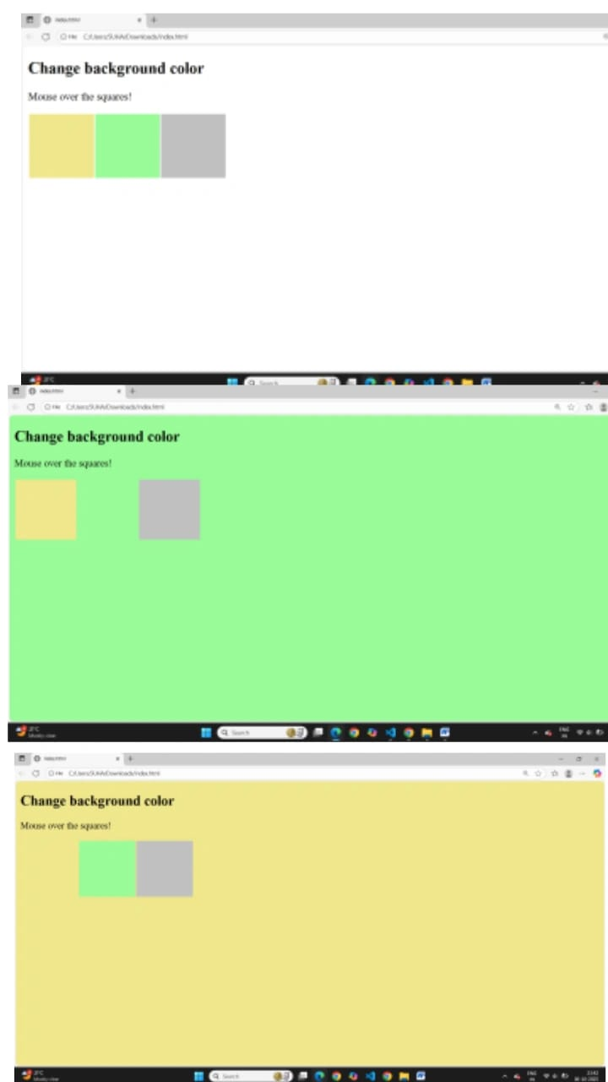

ii. On focus event:
<!DOCTYPE html>
<html>
<body>
Enter your name: <input type="text" onfocus="myFunction(this)">
<p>When the input field gets focus, a function is triggered which changes the background-color.</p>
<script>
function myFunction(x) {
x.style.background = "yellow";
}
</script>
</body>
</html>

